**Following are some of the basic and important characteristics which are common to all developing economies:**

An idea of the characteristics of a developing economy must have been gathered from the above analysis of the definitions of an underdeveloped economy. Various developing countries differ a good deal from each other. Some countries such as countries of Africa do not face problem of rapid population growth, others have to cope with the consequences of rapid population growth. Some developing countries are largely dependent on exports of primary products, others do not show such dependence, and others do not show such dependence.

Some developing countries have weak institutional structure such as lack of property rights, absence of the rule of law and political instability which affect incentives to invest. Besides, there are lot of differences with regard to levels of education, health, food production and availability of natural resources. However, despite this great diversity there are many common features of the developing economies. It is because of common characteristics that their developmental problems are studied within a common analytical framework of development economics.

**Characteristic # 1. Low Per Capita Income:**

The first important feature of the developing countries is their low per capita income. According to the World Bank estimates for the year 1995, average per capita income of the low income countries is $ 430 as compared to $ 24,930 of the high-income countries including U.S.A., U.K., France and Japan. According to these estimates for the year 1995, per capita income was $340 in India, $ 620 in China, $240 in Bangladesh, $ 700 in Sri Lanka. As against these, for the year 1995 per capita income was $ 26,980 in USA, $ 23,750 in Sweden, $ 39,640 in Japan and 40,630 in Switzerland.

It may however be noted that the extent of poverty prevailing in the developing countries is not fully reflected in the per capita income which is only an average income and also includes the incomes of the rich also. Large inequalities in income distribution prevailing in these economies have made the lives of the people more miserable. A large bulk of population of these countries lives below the poverty line.

For example, the recent estimates reveal that about 28 per cent of India’s population (i.e. about 260 million people) lives below the poverty line, that is, they are unable to get even sufficient calories of food needed for minimum subsistence, not to speak of minimum clothing and housing facilities. The situation in other developing countries is no better.

The low levels of per capita income and poverty in developing countries is due to low levels of productivity in various fields of production. The low levels of productivity in the developing economies has been caused by dominance of low-productivity agriculture and informal sectors in their economies, low levels of capital formation – both physical and human (education, health), lack of technological progress, rapid population growth which are in fact the very characteristics of the underdeveloped nature of the developing economies. By utilising their natural resources accelerating rate of capital formation and making progress in technology they can increase their levels of productivity and income and break the vicious circle of poverty operating in them.

It may however be noted that after the Second World War and with getting political freedom from colonial rule, in a good number of the underdeveloped countries the process of growth has been started and their gross domestic product (GDP) and per capita income are increasing.

**Characteristic # 2. Excessive Dependence on Agriculture:**

A developing country is generally predominantly agricultural. About 60 to 75 per cent of its population depends on agriculture and its allied activities for its livelihood. Further, about 30 to 50 per cent of national income of these countries is obtained from agriculture alone. This excessive dependence on agriculture is the result of low productivity and backwardness of their agriculture and lack of modern industrial growth.

In the present-day developed countries, the modern industrial growth brought about structural transformation with the proportion of working population engaged in agriculture falling drastically and that employed in the modern industrial and services sectors rising enormously. This occurred due to the rapid growth of the modern sector on the one hand and tremendous rise in productivity in agriculture on the other.

The dominance of agriculture in developing countries can be known from the distribution of their workforce by sectors. According to estimates made by ILO given in Table 4.1 on an average 61 per cent of workforce of low-income developing countries was employed in agriculture whereas only 19 per cent in industry and 20 per cent in services. On the contrary, in high income, that is, developed countries only 4 per cent of their workforce is employed in agriculture, while 26 per cent of their workforce is employed in industry and 70 per cent in services.

**[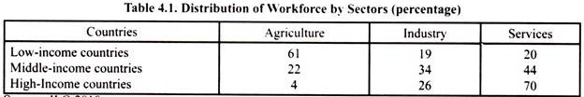](http://cdn.economicsdiscussion.net/wp-content/uploads/2018/02/clip_image002-3.jpg)**

In India at the time of independence about 60 per cent of population was employed in agriculture and with six decades of development the percentage of population engaged in agriculture has fallen to around 50 per cent in 2011-12. However, it is significance to note that the increase in population in non-agriculture sector has found employment not in organised industry and services sector but in informal sector where labour productivity is as low as in agriculture.

Besides, it is important to note though at present (2011-12) agriculture employees 50 per cent of workforce, it contributes only 13 per cent to its GDP. This shows labour productivity in agriculture and informal sector in the Indian economy, as in other developing economies, is due to the fact that the employment in organised industrial and services sector has not grown at a rate commensurate with the increase in population despite recording a higher growth rate in output.

This is due to use of capital-intensive technologies in the organised industrial and services sectors. With the growth of population in the last few decades the demographic preserve on land has increased resulting in fall in land-labour ratio. With this agricultural holdings have become sub-divided into small plots which do not permit the use of efficient methods of cultivation.

In developing countries today, despite their modern industrial growth in the last four decades not much progress has been achieved towards structural transformation in the occupational structure of their economies. Due to the use of highly capital-intensive techniques very few employment opportunities have been created in their organised industrial and services sectors.

When increasing population cannot obtain employment in the modern non-agricultural occupations, such as industry, transport and other services, then the people remain on land and agriculture and do some work which they are able to get. This has resulted in disguised unemployment in agriculture. During the last some decades because of population explosion the pressure of manpower on land in the developing countries has largely increased.

**Characteristic # 3. Low Level of Capital Formation:**

The insufficient amount of physical and human capital is so characteristic a feature in all undeveloped economies that they are often called simply ‘capital-poor’ economies. One indication of the capital deficiency is the low amount of capital per head of population. Not only is the capital stock extremely small, but the current rate of capital formation is also very low. In the early 1950s in most of developing countries investment was only 5 per cent to 8 per cent of the national income, whereas in the United States, Canada, and Western Europe, it was generally from 15 per cent to 30 per cent.

Since then there has been substantial increase in the rate of saving and investment in the developing countries. However, the quantity of capital per head is still very low in them and therefore productivity remains low. For example, in India rate of investment has now (2012-13) risen to about 35 per cent but it still remains a poor country with low level of productivity. This is because as a result of rapid population growth, capital per head is still very low.

ADVERTISEMENTS:

The low level of capital formation in a developing country is due both to the weakness of the inducement to invest and to the low propensity and capacity to save. The rate of saving in developing countries is low primarily because of the low level of national income. In such an economy, the low level of per capita income limits the size of the market demand for manufacturing output which weakens the inducement to invest. The low level of investment also arises as a result of the lack of dynamic entrepreneurship which was regarded by Schumpeter as the focal point in the process of economic development.

At the root of capital deficiency is the shortage of savings. The level of per capita income being quite low, most of it is spent on satisfying the bare necessities of life, leaving a very little margin of income for capital accumulation. Even with an increase in the level of individual incomes in a developing economy, there does not usually follow a higher rate of accumulation because of the tendency to copy the higher levels of consumption prevailing in the advanced countries. Nurkse has called this as “demonstration effect”. It is usually caused through media like films, television or through foreign visits.

Generally, there exist large inequalities in the distribution of incomes in developing countries. This should have resulted in a greater volume of savings available for capital formation. But most often the sector in which the greatest concentration of incomes lies is the one which derives its income primarily from non-entrepreneurial sources such as unearned incomes of rents, interests and monopoly profits.

The attitudes and social values of this sector are often such that it is prone to use its income for ‘conspicuous consumption’, investment in land and real estate, speculative transactions, inventory accumulation and hoarding of gold and jewellery. If these surpluses are channelled into productive investment, they would tend to increase substantially the level of capital formation.

**Characteristic # 4. Rapid Population Growth and Disguised Unemployment:**

The diversity among developing economies is perhaps nowhere to be seen so much in evidence as in respect of the facts of their population in respect of its size, density and growth. While we have examples of India, Pakistan and Bangladesh with their teeming millions and galloping rates of population growth, there are the Latin American countries which are very sparsely populated and whose total population in some cases numbers less than a single metropolitan city in India and China. In several newly emerging countries of Africa too and in some of the Middle Eastern countries the size of their population cannot be regarded as excessive, considering their large expanse. The South- East and Eastern Asia, on the other hand, have large populations.

However, there appears to be a common feature, namely, a rapid rate of population growth. This rate has been rising still more in recent years, thanks to the advances in medical sciences which have greatly reduced the death rate due to epidemics and diseases. While the death rate has fallen sharply, but there has been no commensurate decline in birth rate so that the natural survival rate has become much larger. The great threat of this rapid population growth rate is that it sets at nought all attempts at development in as much as much of the increased output is swallowed up by the increased population.

One important consequence of this rapid rate of population growth is that it throws more and more people on land and into informal sector to eke out their living from agriculture, since alternative occupations do not simultaneously develop and thus are not there to absorb the increasing numbers seeking gainful employment. The resultant pressure of population on land and in informal sector thus gives rise to what has been called “disguised unemployment”.

Disguised unemployment means that there are more persons engaged in agriculture than are actually needed so that the addition of such persons does not add to agricultural output, or putting it alternatively, given the technology and organisation even if some of the persons are withdrawn from land, no fall in production will follow from such withdrawal. As a result, marginal productivity of a wide range of labourers employed in agriculture is zero.

It will be seen from Table 4.2 that in 2009, population of the world was estimated at 6,775 million in 2009 and its annual population growth in 1990-2009 was 1.3 per cent. The population growths in low-income developing countries have been 2.3 per cent per annum during 1990-2009 and of middle income developing countries as a whole has been 1.3 per cent per annum. As against this, population growth rate in high income countries (i.e., developed countries) was 0.7% per annum. That is, population in developing countries has been growing at a much faster rate as compared to the developed countries.

In Table 4.2, we have given the dependency ratio on the working population. Both children and boys below the age of 15 years (i.e., young ones) and the old people above the age of 65 years and above represent dependency burden as they are unproductive members and are financially dependent on the working population.

The bad effect of this dependency burden for developing countries is that it reduces saving rate of the community and therefore adversely affects economic growth. It will be seen from Table 4.2 that the dependency burden of young persons (i.e., below the age of 15 years) in case of low-income countries is very high at 69%, whereas the dependency burden of old people on the working population is much lower, only 6 per cent. As against this, for high income countries dependency burden of old persons is relatively very high being 23 per cent.

**[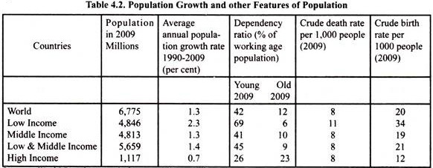](http://cdn.economicsdiscussion.net/wp-content/uploads/2018/02/clip_image004-1.jpg)**

ADVERTISEMENTS:

**Underutilization of Natural Resources:**

The natural resources in an underdeveloped economy are either unutilised or underutilised. Generally speaking, under-developed countries are not deficient in land, water, mineral, forest or power resources, though they may be untapped. In other words, they constitute only potential resources. The main problem in their case is that such resources have not been fully and properly utilised due to various difficulties such as shortage of capital, primitive technology and the small size of the market.

**Characteristic # 5. Lower Levels of Human Capital:**

Human capital – education, health and skills – are of crucial importance for economic development. In our analysis of human development index (HDI) we noted that there is great disparity in human capital among the developing and developed countries. The developing countries lack in human capital that is responsible for low productivity of labour and capital in them.

Lack of education manifests itself in lower enrolment rate in primary, secondary and tertiary educational institutions which impact knowledge and skills of the people. Lower levels of education and skills are not conducive for the development of new industries and for absorbing new technologies to achieve higher levels of production. Besides, lack of education and skills makes people less adaptable to change and lowers the ability to organise and manage industrial enterprises. Further, in countries like India, advantage of demographic dividend can be taken only if the younger persons can be educated, healthy and equipped with appropriate skills so that they can be employed in productive activities.

The data of various education indicators is given in Table 4.3. It will be seen from this table that as compared to high income countries enrolment in secondary and tertiary educational institutions was 38% and 63% of person of relevant age group in 2009 as compared to 100 per cent in high-income developed countries.

Similarly, enrolment rate in tertiary educational institutions which impart higher liberal, managerial and technical education in developing countries of low income and lower middle income is 6 per cent and 19 per cent respectively of the relevant age group as compared to 67 per cent in high-income developed countries. It will be seen from Table 4.3 that in India enrolment for secondary education is 60 per cent and in China 78 per cent of relevant age group.

Similarly, Table 4.3 reveals that adult literacy rate (percentage of population of ages 15 and older that can read and write a short simple statement in their everyday life) is much lower (62% in low income and 80% in lower middle income developing countries) in 2009 as compared to 98% in high income developed countries. In India adult literacy rate is only 63 per cent in 2009 whereas it is much higher in China (94 %) and Brazil (90 %) as compared to 98% in high-income developed countries.

It is evident from above that educational and skill levels in developing countries are much lower as compared to developed countries. This lowers the quality of the people of developing countries as productive agents and wealth creators.

**[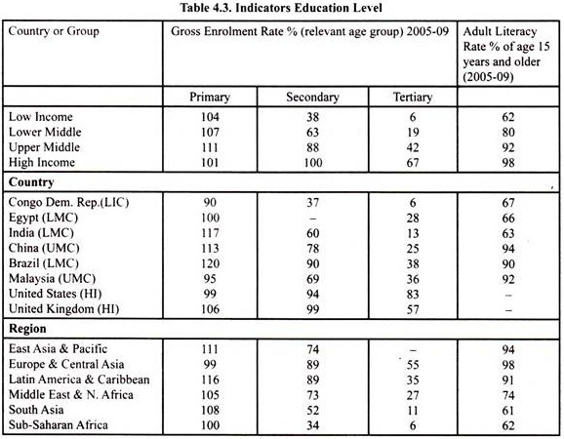](http://cdn.economicsdiscussion.net/wp-content/uploads/2018/02/clip_image006-1.jpg)**

**Health:**

Likewise, health, the other important human resource, is a key factor that determines efficiency or productivity of the people. The people who are undernourished and malnourished often suffer from sickness cannot be efficient and therefore cannot contribute much to the increase in productivity.

Besides, health enjoyed by the people is good in itself as it directly increases the happiness and welfare of the people, Lower health of the people of developing countries is manifested lower life expectancy at birth, higher mortality rate of children under 5 years age, undernourishment and malnourishment (i.e., underweight children) of the people and access to improved sanitation facilities. Though health conditions in developing countries have greatly improved in the last some decades of development, there are still important differences between them and developed countries. The data of various health indicators is given in Table 4.4.

**[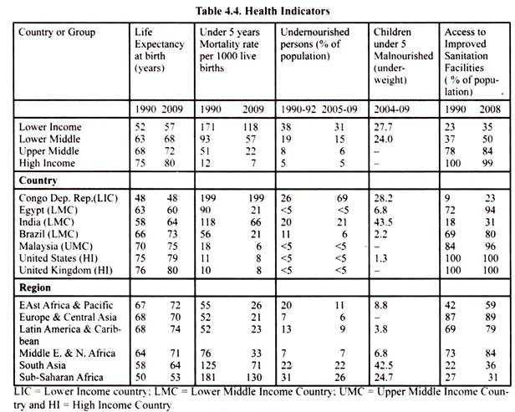](http://cdn.economicsdiscussion.net/wp-content/uploads/2018/02/clip_image008.jpg)**

It will be seen from Table 4.4 that life expectancy at birth in low income (LIC) and lower middle income countries (LMC) is 57% and 68% respectively in 2009 as against 80% in high income developed countries. Health conditions in South Asia and Sub-Saharan Africa are highly deplorable and they continue to suffer from problems of acute undernourishment, malnourishment and children’s mortality rate. Mortality rate of under 5 years age children per 1000 live births in 2009 was 118 in low income countries (LIC) and 57 in lower middle income countries (LMC). In India which is a lower middle income country, under 5-years mortality rate in 2009 was relatively high at 66 as against only 8 per 1000 live births in the United States and United Kingdom.

Two types of statistical data regarding nutrition are given in Table 4.4. First, undernourished persons in a country as per cent of population, undernourishment refers to dietary energy consumption that is continuously below minimum requirement for maintaining healthy life so as to carry out light physical activity with an acceptable minimum weight. Second, Child nutrition which is here measured by malnourishment of children under 5 year’s age who are underweight. This un-nourishment impairs the working capacity of the individuals and also makes them unable to acquire education and skills needed for high productivity job.

It will be seen from Table 4.4 that percentage of under-weight persons to total population is very high in developing countries 31 per cent in low income countries (LIC) and 15 per cent in lower middle income countries whereas it is very low at 5% in high income developed countries in the year 2009. In India the percentage of undernourished persons to total population was high at 21 per cent but Brazil has succeeded in lowering it to 6 per cent of the population.

As regards the prevalence of malnourishment, the condition in India is shocking as it has the highest, 43.5%, of children less than 5 years age whereas it is only 1.3% in 2009. The same is the case with regard to access to improved sanitation facilities. It will be seen from Table 4.4 that in India 31 per cent of population has access to improved sanitation facilities as against 100 per cent in the United States and United Kingdom.

**Characteristic # 6. Dualistic Structure of the Underdeveloped Economies:**

An important feature of developing economies, especially those which are marked by surplus labour is that they have a dualistic structure. This dualistic character of these economies has been held to be the cause of unemployment and underemployment existing in them. Keeping in view this dualistic structure of less developed economies, important models of income and employment have been propounded.

Famous Lewis model of economic development with unlimited supplies of labour and Fei-Ranis model of “Development in a Labour Surplus Economy” explain how in dualistic economies, the unemployed and underemployed labour in the traditional sector is drawn into a modern high productivity sector.

The concept of dualism was first of all introduced into the development analysis by Dr. J.H. Boeke but he emphasised the social dualism, according to which there is sharp contrast between the social systems characterising the two broad sectors of the economy, one in which the original social system with its subsistence or pre-capitalist nature, limited wants, non-economic behaviour and low level of economic and social welfare prevails, and the other where imported capitalist system with its modern system of industrial organisation, wage employment, unlimited wants and positive behaviour to economic incentives exists.

However, it is technological dualism rather than Boeke’s social dualism which has an important bearing on the problem of economic growth and surplus labour in the developing countries. According to the concept of technological dualism, the important difference between the traditional and the modern sectors lies in the difference between the production techniques or technologies used. In the small modern sector consisting of large-scale manufacturing and mining which provides wage employment, highly capital-intensive techniques imported from the developed countries are used.

On the other hand, in the large traditional sector covering agriculture, handicrafts and allied activities, in which there exist extended family system and self-employment, labour-intensive technology is generally used. As a result of the difference in technologies used, the labour productivity and levels of earnings in the modern sector are much higher than those in the traditional sector.

Moreover, since the technology used in the modern sector is highly capital-intensive, the growth of this sector has not absorbed adequate amount of labour in high productivity and high wage employment. With the explosive rate of growth of population and labour force and the limited creation of employment opportunities in the modern sectors because of the highly capital-intensive technology, surplus labour has emerged in the agriculture and services. It has been possible for agriculture to contain the surplus labour because of the prevalence of extended family system in which both work and income are shared by the family members.

We thus see that the problem of unemployment and underemployment in less developed economies has been intensified by the technological dualism caused by the use, in the modern manufacturing and mining, of capital-intensive technology imported from abroad which is wholly unsuitable to the factor endowments of these less developed economies with abundant labour and small capital.

The unemployment and underemployment in these less developed economies are not only due to the slow growth of capital or low rate of investment, it is also due to the highly capital-intensive techniques used in the modern sector. This technological dualism with the fact that modern sector has limited labour-absorptive capacity contains important implications for development strategy to be framed for less developed countries like India with surplus labour.

**Need for Development:**

There is a very urgent need for economic development in the underdeveloped or poor countries. Economic development is needed so that living standards of their people may be raised. What is more important is that economic development of the poor countries is necessary from the point of view of the richer countries. What do we find today? The world is divided into two parts- one of the poor and the other of the rich which is continuously becoming richer.

Such a situation threatens the economic and political stability of the world. Unless the poor countries are enabled to share the general prosperity, their condition will become more and more difficult. It is the relative difference between the rich and poor countries which will make the poor countries discontented. Ever-increasing discontent in the poor countries is bound, sooner or later, to aggravate the already explosive situation in the world.

As the gulf between the rich and poor countries widens, the tension in the world will grow. The poor countries will agitate more and more for a share in prosperity and, consequently, their demand on the richer countries will grow louder and louder in volume and intensity. There is ample evidence in the world of the fact that when nations cannot solve their domestic problems, their governments plunge them into war with their neighbours who may be prosperous. It is thus in the interest of world peace and harmony that the poor countries are enabled to remove or reduce their poverty.

There is a growing and legitimate desire of the poor nations to eradicate poverty. The desire to develop is keenly felt by different sections of their population. Their desire to develop is natural and understandable because they experience acute physical sufferings as a result of appallingly miserable economic conditions in which they live. The masses in the poor countries constantly face hunger, illiteracy, sickness and are forced to eke out a life of extreme poverty.

**Note that, according to the new view as made popular by Amartya Sen economic development is needed mainly for two reasons:**

(1) The removal of poverty,

(2) Enlargement of human capabilities and freedoms.

For the removal of poverty capabilities of the poor should be enhanced so that they should be able to meet their minimum basic needs which include getting adequate food, health, clothing and shelter. To achieve these economic growths is necessary but not sufficient. Therefore, for removal of poverty, direct anti-poverty measures such as generation of enough employment opportunities are taken.

Secondly, as emphasized by Amartya Sen, development is needed so that people should enjoy freedom and life of valued functioning. To quote Amartya Sen, “The valued functioning may vary from elementary ones, such as being adequately nourished and being free from avoidable diseases to very complex activities or personal states such as being able to take part in the life of community and having self-respect”. Thus, according to Amartya Sen, freedom of choice, and control of one’s own life are central aspects of well-being for which true development is needed.

Times are gone when people believed in their destiny or kismet. They are no longer prepared to reconcile to their poverty as resulting from fate. They have now realized that the solution of the problem of poverty lies in economic development. This realization has been further strengthened by the ever-increasing contacts and communications between such countries and the developed countries. The awareness of the possibilities of development is growing every day. Already, the upper sections of society in developing countries are imitating the living standards prevalent in the rich countries.

The desire for development has followed the political freedom of the many poor countries from foreign rule. It has now been realised that political freedom without economic freedom and prosperity has no meaning. Political independence has naturally raised expectations of the people in the economic sphere. No wonder that people of these countries which have won freedom from the colonial rule aspire to develop economically and that in the shortest possible time.